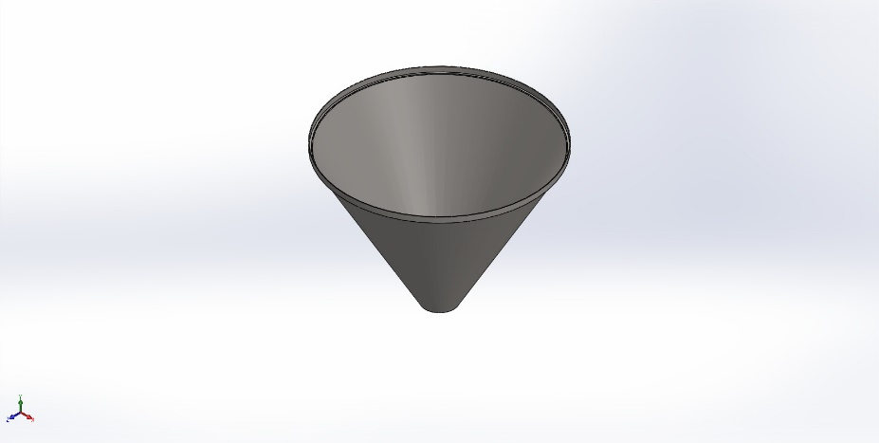
  Simulation of hopper2
  Date: Tuesday, January 13, 2026
  Designer: Solidworks
  Study name: Static 1
  Analysis type: Static
  Table of Contents
  Description 1
  Assumptions 2
  Model Information 2
  Study Properties 3
  Units 3
  Material Properties 4
  Loads and Fixtures 4
  Connector Definitions 5
  Interaction Information 5
  Mesh information 5
  Sensor Details 5
  Resultant Forces 6
  Beams 6
  Study Results 7
  Conclusion 9

Description
No Data

Assumptions

Model Information

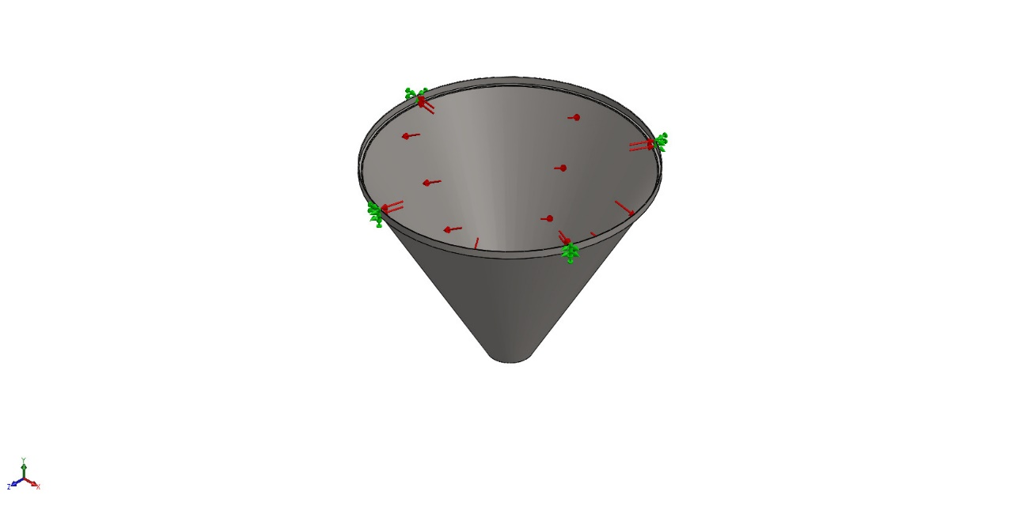
Model name: hopper2
Current Configuration: Default
Solid Bodies
Document Name and Reference | Treated As | Volumetric Properties | Document Path/Date Modified
Shell2  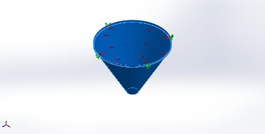 | Solid Body | Mass:5.17315 kg  Volume:0.00064203 m^3  Density:8,057.49 kg/m^3  Weight:50.6969 N | C:\Users\user1\Desktop\VFFS\التعبئة\التعبئة\assemply\hopper2.SLDPRT

Study Properties
Study name | Static 1
Analysis type | Static
Mesh type | Solid Mesh
Thermal Effect: | On
Thermal option | Include temperature loads
Zero strain temperature | 298 Kelvin
Include fluid pressure effects from SOLIDWORKS Flow Simulation | Off
Solver type | Automatic
Inplane Effect: | Off
Soft Spring: | Off
Inertial Relief: | Off
Incompatible bonding options | Automatic
Large displacement | Off
Compute free body forces | On
Friction | Off
Use Adaptive Method: | Off
Result folder | SOLIDWORKS document (C:\Users\user1\Desktop\VFFS\التعبئة\التعبئة\assemply)

Units
Unit system: | SI (MKS)
Length/Displacement | mm
Temperature | Kelvin
Angular velocity | Rad/sec
Pressure/Stress | N/m^2

Material Properties
Model Reference | Properties | Components
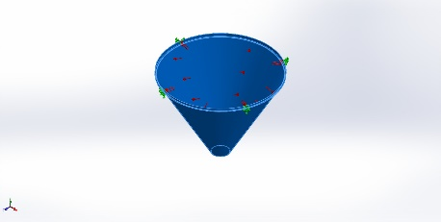 |  | SolidBody 1(Shell2)(hopper2)
  Name: | AISI 304
  Model type: | Linear Elastic Isotropic
  Default failure criterion: | Max von Mises Stress
  Yield strength: | 2.06807e+08 N/m^2
  Tensile strength: | 5.17017e+08 N/m^2
  Elastic modulus: | 1.9e+11 N/m^2
  Poisson's ratio: | 0.29
  Mass density: | 8,000 kg/m^3
  Shear modulus: | 7.5e+10 N/m^2
  Thermal expansion coefficient: | 1.8e-05 /Kelvin
Curve Data:N/A

Loads and Fixtures
Fixture name | Fixture Image | Fixture Details
Fixed-1 | 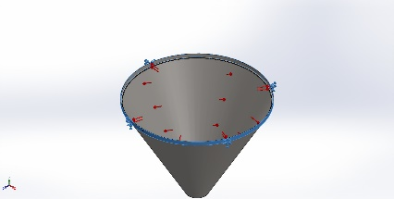
  Entities: | 1 face(s)
  Type: | Fixed Geometry
Resultant Forces
Components | X | Y | Z | Resultant
Reaction force(N) | 3.8594e-05 | 657.529 | 1.12057e-05 | 657.529
Reaction Moment(N.m) | 0 | 0 | 0 | 0

Load name | Load Image | Load Details
Pressure-1 | 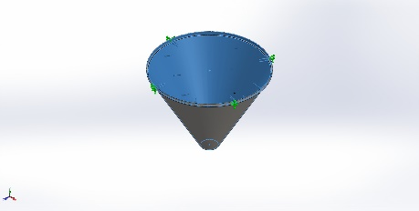
  Entities: | 2 face(s)
  Type: | Normal to selected face
  Value: | 4,300
  Units: | N/m^2
  Phase Angle: | 0
  Units: | deg

Connector Definitions
No Data

Interaction Information
No Data

Mesh information
Mesh type | Solid Mesh
Mesher Used: | Blended curvature-based mesh
Jacobian points for High quality mesh | 16 Points
Maximum element size | 11.6625 mm
Minimum element size | 8.18419 mm
Mesh Quality | High

Mesh information - Details
Total Nodes | 39638
Total Elements | 19779
Maximum Aspect Ratio | 29.951
% of elements with Aspect Ratio < 3 | 1.44
Percentage of elements with Aspect Ratio > 10 | 5.18
Percentage of distorted elements | 0
Time to complete mesh(hh;mm;ss): | 00:00:04
Computer name:

Sensor Details
No Data

Resultant Forces

Reaction forces
Selection set | Units | Sum X | Sum Y | Sum Z | Resultant
Entire Model | N | 3.8594e-05 | 657.529 | 1.12057e-05 | 657.529

Reaction Moments
Selection set | Units | Sum X | Sum Y | Sum Z | Resultant
Entire Model | N.m | 0 | 0 | 0 | 0

Free body forces
Selection set | Units | Sum X | Sum Y | Sum Z | Resultant
Entire Model | N | 1.83284e-05 | -0.00140002 | -2.87592e-06 | 0.00140014

Free body moments
Selection set | Units | Sum X | Sum Y | Sum Z | Resultant
Entire Model | N.m | 0 | 0 | 0 | 1e-33

Beams
No Data

Study Results

Name | Type | Min | Max
Displacement1 | URES: Resultant Displacement | 0.000e+00mm  Node: 9 | 9.088e-04mm  Node: 25479
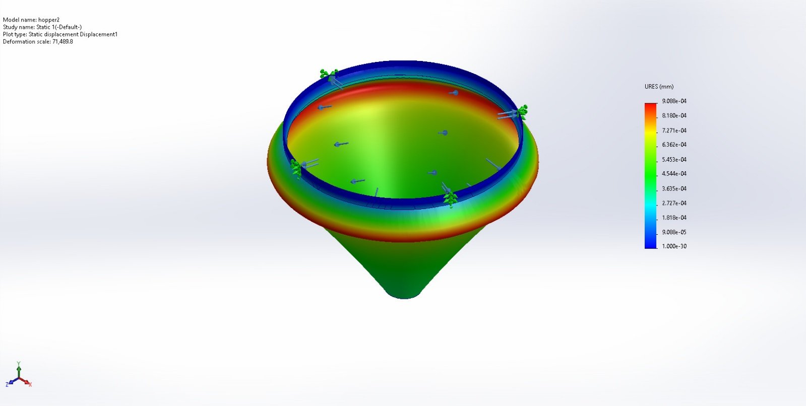
hopper2-Static 1-Displacement-Displacement1

Name | Type | Min | Max
Stress1 | VON: von Mises Stress | 9.452e+03N/m^2  Node: 9091 | 2.296e+06N/m^2  Node: 10760
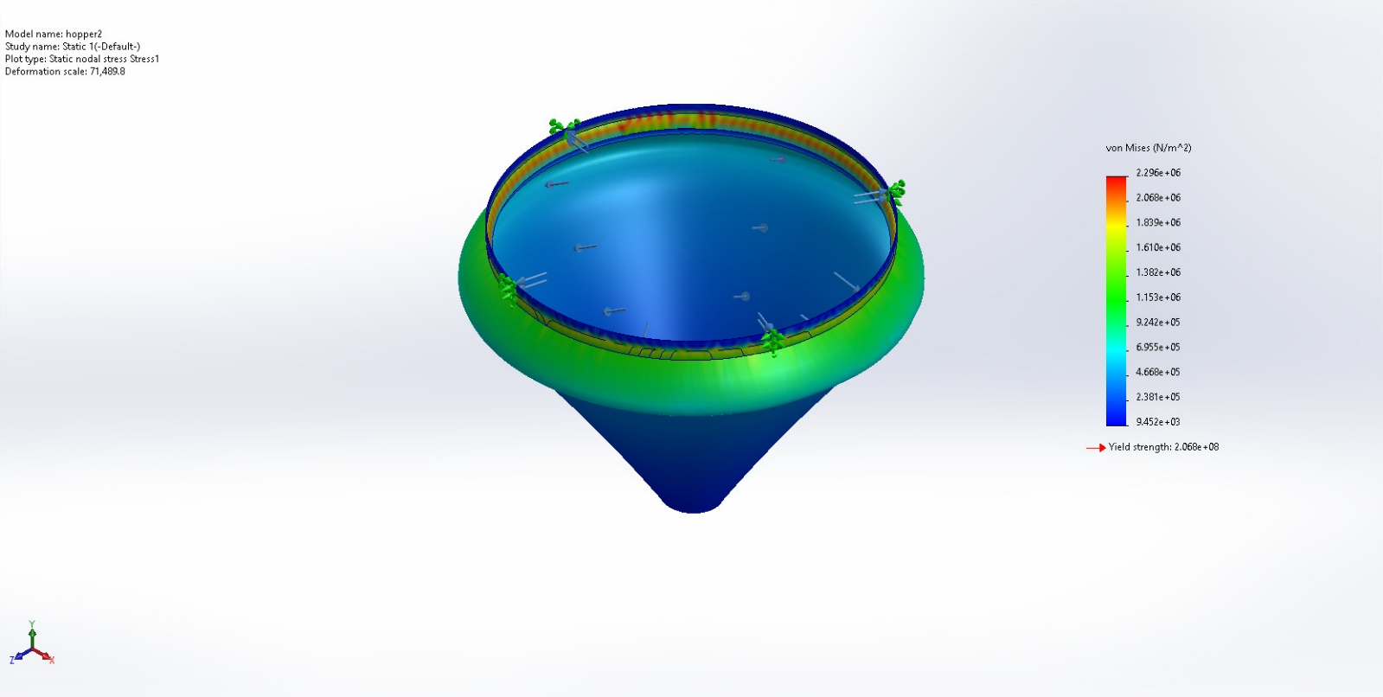
hopper2-Static 1-Stress-Stress1

Name | Type | Min | Max
Factor of Safety1 | Max von Mises Stress | 90.056  Node: 10760 | 21,878.701  Node: 9091
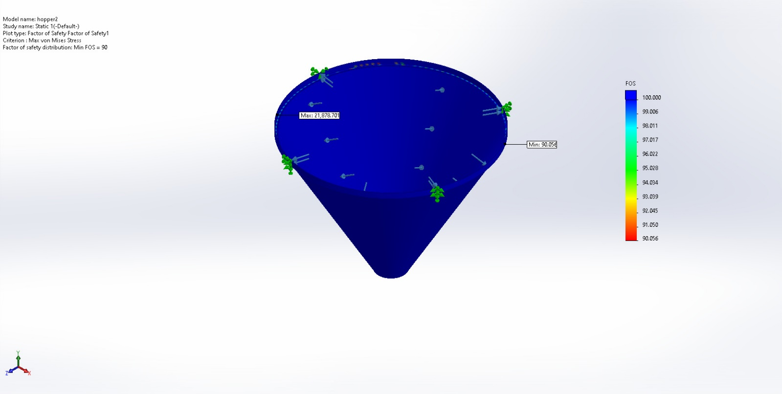
hopper2-Static 1-Factor of Safety-Factor of Safety1

Name | Type | Min | Max
Strain1 | ESTRN: Equivalent Strain | 4.278e-08  Node: 9091 | 1.039e-05  Node: 10760
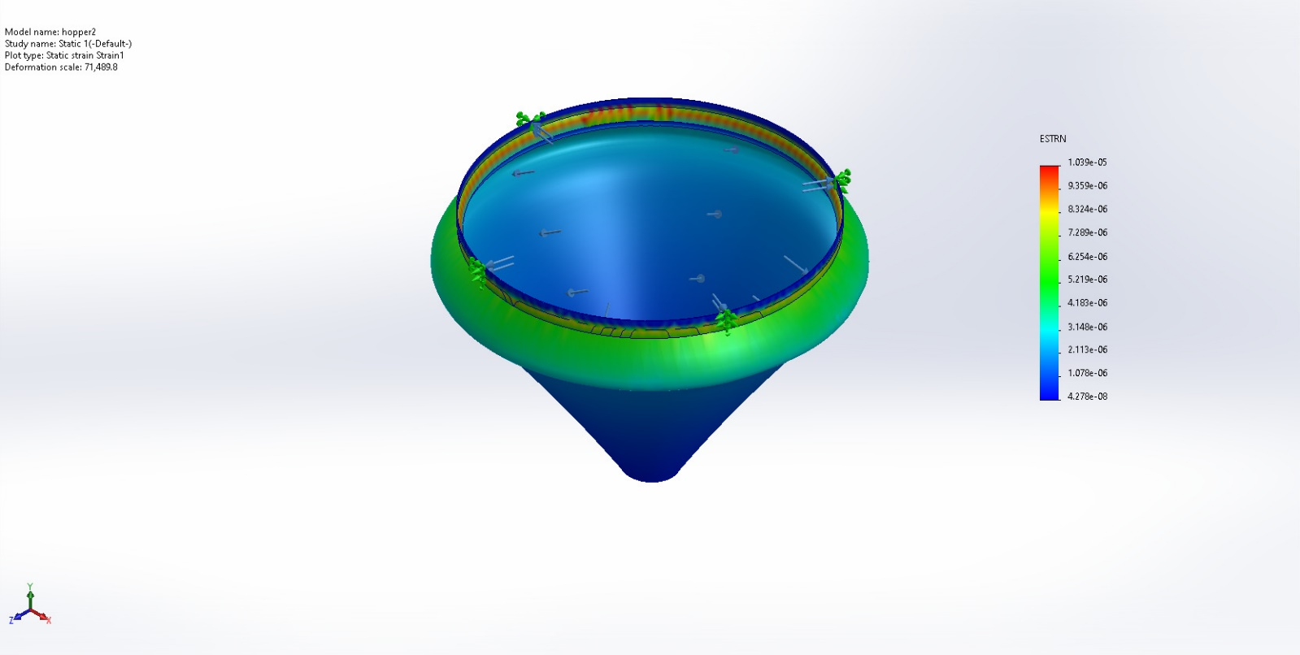
hopper2-Static 1-Strain-Strain1

Conclusion

